SOLAR LEARNING DOCUMENTATION

By: John Carlo Cunanan

**Main page**

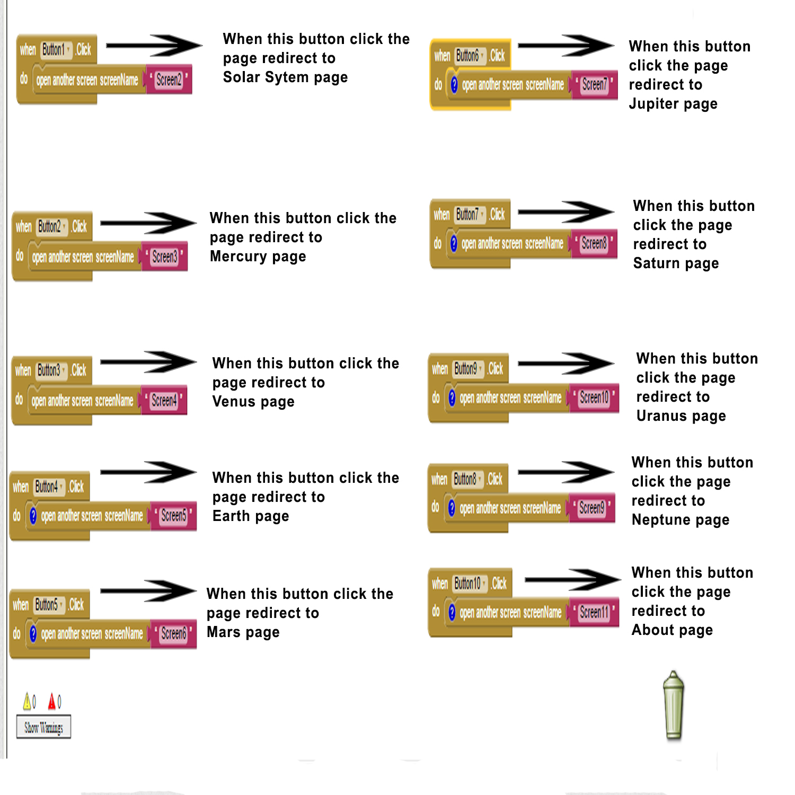

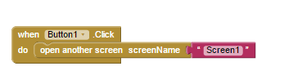 **Solar System Page**

 **Mercury Page**

 **Venus Page**

 **Earth Page**

 **Mars Page**

 **Jupiter Page**

**Saturn Page**



**Uranus Page**



**Neptune Page**



**About Page**

